Федеральное государственное автономное образовательное учреждение высшего образования
«Национальный исследовательский университет ИТМО»
Факультет программной инженерии и компьютерной техники

Отчет по лабораторной работе №4

по дисциплине «Вычислительная математика»

Вариант 11

Выполнили:
Студенты группы P3265
Кручинина Дарья Сергеевна
Москвитина Полина

Преподаватель:
Машина Екатерина Алексеевна
Цели работы
Найти функцию, являющуюся
наилучшим приближением заданной табличной функции по методу
наименьших квадратов.

Порядок выполнения работы
Вычислительная реализация задачи
Вычислительная часть лабораторной работы должна быть представлена
только в отчете.
Задание:
1. Сформировать таблицу табулирования заданной функции на
указанном интервале (см. табл. 1)
2. Построить линейное и квадратичное приближения по 11 точкам
заданного интервала;
3. Найти среднеквадратические отклонения для каждой
аппроксимирующей функции. Ответы дать с тремя знаками после
запятой;
4. Выбрать наилучшее приближение;
5. Построить графики заданной функции, а также полученные
линейное и квадратичное приближения;
6. Привести в отчете подробные вычисления.

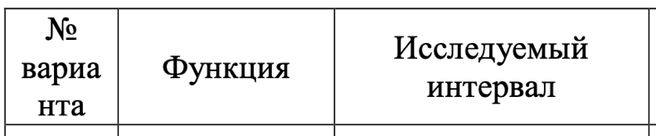
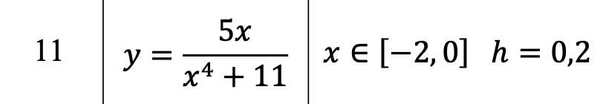

Таблица табулирования:

X_{i} | -2 | -1.8 | -1.6 | -1.4 | -1.2 | -1.0 | -0.8 | -0.6 | -0.4 | -0.2 | 0
Y_{i} | -0.37 | -0.419 | -0.456 | -0.472 | -0.459 | -0.417 | -0.351 | -0.27 | -0.181 | -0.091 | 0

Линейное приближение:
$$f \left(x\right)=ax+b$$

Вычисляем суммы:
$$SX =\sum_{i=1}^{n}{x_{i}= -11}$$
$$SXX=\sum_{i=1}^{n}{x_{i}^{2}= 15,4}$$
$$SY =\sum_{i=1}^{n}{y_{i}= -3,486}$$
$$SXY =\sum_{i=1}^{n}{x_{i}y_{i}= 4,386}$$
Получаем систему линейных уравнений:

$$\left\{\begin{aligned}15,4a+\left(-11\right)b= 4,386 \\ \\ \left(-11\right)a+11b= -3,486\end{aligned}\right.$$

Из которой находим (правило Крамера):

a = 0,205
b = -0,112

Вычисляем значения аппроксимирующей функции $f \left(x\right)$:

$$f \left(x\right)=0,205x-0,0112$$

X_{i} | -2 | -1.8 | -1.6 | -1.4 | -1.2 | -1.0 | -0.8 | -0.6 | -0.4 | -0.2 | 0
Y_{i} | -0.37 | -0.419 | -0.456 | -0.472 | -0.459 | -0.417 | -0.351 | -0.27 | -0.181 | -0.091 | 0
$$f \left(x\right)$$ | -0.522 | -0.481 | -0.44 | -0.399 | -0.358 | -0.317 | -0.276 | -0.235 | -0.194 | -0.153 | -0.112
E_{i} | -0.152 | -0.062 | 0.016 | 0.073 | 0.101 | 0.100 | 0.075 | 0.035 | -0.013 | -0.062 | -0.112

Квадратичное приближение:
$$f \left(x\right)=a+bx+cx^{2}$$

Вычисляем суммы:

$$\sum_{i=1}^{n}{x_{i}= -11}$$
$$\sum_{i=1}^{n}{x_{i}^{2}= 15,4}$$
$$\sum_{i=1}^{n}{x_{i}^{3}= -24,2}$$
$$\sum_{i=1}^{n}{x_{i}^{4}= 40,533}$$
$$\sum_{i=1}^{n}{y_{i}= -3,486}$$
$$\sum_{i=1}^{n}{x_{i}y_{i}= 4,386}$$
$$\sum_{i=1}^{n}{x_{i}^{2}y_{i}= -6,362}$$

Получили систему линейных уравнений, решив которую, определим значения
коэффициентов эмпирической формулы:

$$\left\{\begin{aligned}11a-11b+15,4c= -3,486 \\ -11a+15,4b-24,2c=4,386 \\ 15,4a-24,2b+40,533c= -6,362\end{aligned}\right.$$
Из которой находим:

a = 0,027
b = 0,668
c = 0,232

$$f \left(x\right)=0,027+0,668x+0,232x^{2}$$

X_{i} | -2 | -1.8 | -1.6 | -1.4 | -1.2 | -1.0 | -0.8 | -0.6 | -0.4 | -0.2 | 0
Y_{i} | -0.37 | -0.419 | -0.456 | -0.472 | -0.459 | -0.417 | -0.351 | -0.27 | -0.181 | -0.091 | 0
$$f \left(x\right)$$ | -0.383 | -0.425 | -0.449 | -0.454 | -0.441 | -0.409 | -0.359 | -0.291 | -0.203 | -0.098 | -0.026
E_{i} | -0.013 | -0.006 | 0.007 | 0.018 | 0.018 | 0.008 | -0.008 | -0.021 | -0.022 | -0.007 | -0.026

Среднеквадратические отклонения:

$δ$ (отклонение линейного приближения) $= \sqrt{\frac{\sum_{i=1}^{n}{E_{i}^{2}}}{n}}≈0,083$

$δ$ (отклонение квадратичного приближения) $= \sqrt{\frac{\sum_{i=1}^{n}{E_{i}^{2}}}{n}}≈0,016$

Наилучшим приближением является квадратичное, так как оно меньше

Графики:

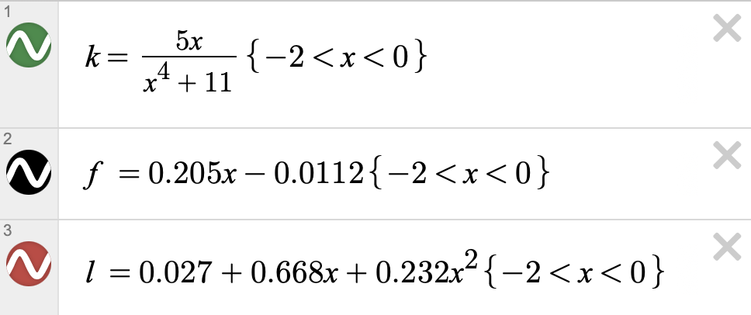

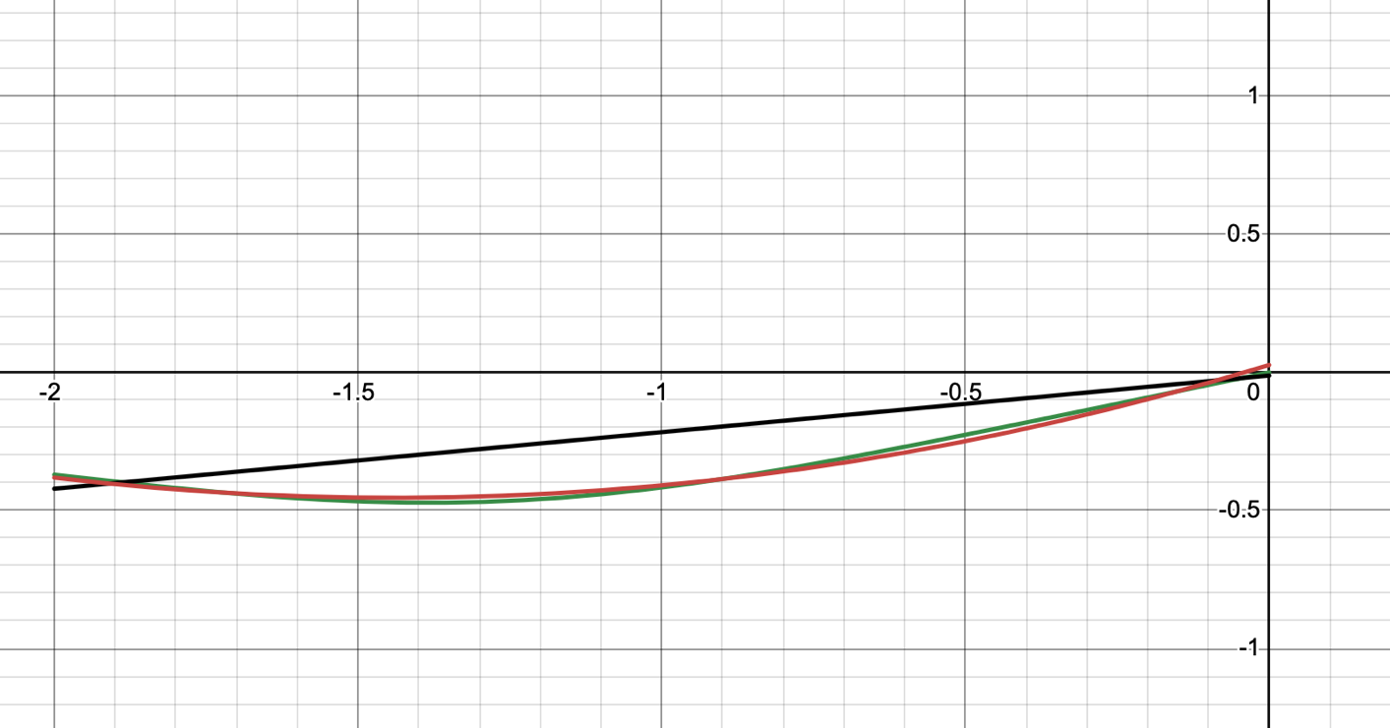

Программная реализация задачи

Для исследования использовать:
линейную функцию,
полиномиальную функцию 2-й степени,
полиномиальную функцию 3-й степени,
экспоненциальную функцию,
логарифмическую функцию,
степенную функцию.

from __future__ import annotations

import math
import os
from parser import Parser
from dto import PointTable, ApproxRes
from approx import APPROXIMATORS
from utils import draw_graph

def main() -> None:
os.chdir('/' + '/'.join(__file__.split('/')[:-2]) + '/resources')
data: PointTable | None = Parser.parse_table_from_file(input('Type input filename -> '))
if data is None:
return

Parser.clear_file()
min_sko: float = math.inf
min_type: str | None = None
for approximator in APPROXIMATORS:
res: ApproxRes = approximator(data)
Parser.print_res(res)

if res.data is not None:
draw_graph(res.data, res.type)
if res.data.sko < min_sko:
min_sko = res.data.sko
min_type = res.type

if min_type is not None:
print(f'Best approximator is {min_type} with sko = {min_sko:.4g}')

if __name__ == '__main__':
main()

import math

from dto import *
from utils import avg
from enum import Enum
from slau_solver.matrix import Equation

def calc_pirson_kf(def_data: DataTable) -> float:
x_list: list[float] = def_data.x_list
y_list: list[float] = def_data.y_list

n: int = len(x_list)
avg_x = avg(x_list)
avg_y = avg(y_list)

return (sum([(x_list[i] - avg_x) * (y_list[i] - avg_y) for i in range(n)]) /
math.sqrt(sum([(x_list[i] - avg_x) ** 2 for i in range(n)]) *
sum([(y_list[i] - avg_y) ** 2 for i in range(n)])
))

def calc_det_kf(def_data: DataTable) -> float:
phi_list: list[float] = def_data.phi_x
y_list: list[float] = def_data.y_list

n: int = len(phi_list)
avg_phi = avg(phi_list)

return (1 - sum([(y_list[i] - phi_list[i]) ** 2 for i in range(n)]) /
sum([(y_list[i] - avg_phi) ** 2 for i in range(n)]))

def calc_sko(eps: list[float]) -> float:
n: int = len(eps)
return math.sqrt(sum([eps[i] ** 2 for i in range(n)]) / n)

def get_def_data(points: PointTable, func: callable) -> DataTable:
x_list = points.get_all_x()
y_list = points.get_all_y()
phi_x = [func(x) for x in x_list]
eps = [phi_x[i] - y_list[i] for i in range(points.n)]

return DataTable(x_list, y_list, phi_x, eps)

def calc_linear_kfs(points: PointTable) -> tuple[float, float]:
sx, sy, sxx, sxy, n = (points.sx(), points.sy(),
points.sxx(), points.sxy(), points.n)

eq: Equation = Equation.create([
[sxx, sx],
[sx, n],
[sxy, sy]
])
eq.solve()
a, b = eq.answers.elems
return a, b

def approx_linear(points: PointTable) -> ApproxRes:
a, b = calc_linear_kfs(points)

callback: callable = lambda x: a * x + b
func_view: str = f'{a:.3g}x'
if b > 0:
func_view += f' + {b:.3g}'
elif b < 0:
func_view += f' - {-b:.3g}x'

def_data: DataTable = get_def_data(points, callback)

return ApproxRes(
type='Линейная аппроксимация',
data=LinearApproxData(
func_view=func_view,
callback=callback,
sko=calc_sko(def_data.eps),
x_list=def_data.x_list,
y_list=def_data.y_list,
phi_x=def_data.phi_x,
eps=def_data.eps,
pirson_kf=calc_pirson_kf(def_data),
det_kf=calc_det_kf(def_data)
),
error_message=None
)

def approx_quad(points: PointTable) -> ApproxRes:
sx, sxx, s3x, s4x, sy, sxy, sxxy, n = \
(points.sx(), points.sxx(), points.s3x(), points.s4x(),
points.sy(), points.sxy(), points.sxxy(), points.n)

eq: Equation = Equation.create([
[s4x, s3x, sxx],
[s3x, sxx, sx],
[sxx, sx, n],
[sxxy, sxy, sy]
])
eq.solve()
a, b, c = eq.answers.elems

callback: callable = lambda x: a * x * x + b * x + c
func_view: str = f'{a:.3g}x^2'
if b > 0:
func_view += f' + {b:.3g}x'
elif b < 0:
func_view += f' - {-b:.3g}x'
if c > 0:
func_view += f' + {c:.3g}'
elif c < 0:
func_view += f' - {-c:.3g}'

def_data: DataTable = get_def_data(points, callback)

return ApproxRes(
type='Квадратичная аппроксимация',
data=ApproxData(
func_view=func_view,
callback=callback,
sko=calc_sko(def_data.eps),
x_list=def_data.x_list,
y_list=def_data.y_list,
phi_x=def_data.phi_x,
eps=def_data.eps,
det_kf=calc_det_kf(def_data)
),
error_message=None
)

def approx_cube(points: PointTable) -> ApproxRes:
sx, sxx, s3x, s4x, s5x, s6x, sy, sxy, sxxy, s3xy, n = \
(points.sx(), points.sxx(), points.s3x(), points.s4x(),
points.s5x(), points.s6x(), points.sy(), points.sxy(),
points.sxxy(), points.s3xy(), points.n)
eq: Equation = Equation.create([
[s6x, s5x, s4x, s3x],
[s5x, s4x, s3x, sxx],
[s4x, s3x, sxx, sx],
[s3x, sxx, sx, n],
[s3xy, sxxy, sxy, sy]
])
eq.solve()
a, b, c, d = eq.answers.elems

callback: callable = lambda x: a * (x ** 3) + b * (x ** 2) + c * x + d
func_view: str = f'{a:.3g}x^3'
if b > 0:
func_view += f' + {b:.3g}x^2'
elif b < 0:
func_view += f' - {-b:.3g}x^2'
if c > 0:
func_view += f' + {c:.3g}x'
elif c < 0:
func_view += f' - {-c:.3g}x'
if d > 0:
func_view += f' + {d:.3g}'
elif d < 0:
func_view += f' - {-d:.3g}'

def_data: DataTable = get_def_data(points, callback)

return ApproxRes(
type='Кубическая аппроксимация',
data=ApproxData(
func_view=func_view,
callback=callback,
sko=calc_sko(def_data.eps),
x_list=def_data.x_list,
y_list=def_data.y_list,
phi_x=def_data.phi_x,
eps=def_data.eps,
det_kf=calc_det_kf(def_data)
),
error_message=None
)

def approx_exp(points: PointTable) -> ApproxRes:
if not points.log_y_is_safe():
return ApproxRes(
type='Экспоненциальная аппроксимация',
data=None,
error_message="Can't approximate with negative ordinates"
)
points_copy: PointTable = points.copy()
for i in range(points.n):
points_copy[i].y = math.log(points_copy[i].y)

b, A = calc_linear_kfs(points_copy)
a = math.exp(A)

callback: callable = lambda x: a * math.exp(b * x)
func_view: str = f'{a:.3g}e^({b:.3g}x)'
def_data: DataTable = get_def_data(points, callback)

return ApproxRes(
type='Экспоненциальная аппроксимация',
data=ApproxData(
func_view=func_view,
callback=callback,
sko=calc_sko(def_data.eps),
x_list=def_data.x_list,
y_list=def_data.y_list,
phi_x=def_data.phi_x,
eps=def_data.eps,
det_kf=calc_det_kf(def_data)
),
error_message=None
)

def approx_log(points: PointTable) -> ApproxRes:
if not points.log_x_is_safe():
return ApproxRes(
type='Логарифмическая аппроксимация',
data=None,
error_message="Can't approximate with negative abscisses"
)

points_copy: PointTable = points.copy()
for i in range(points.n):
points_copy[i].x = math.log(points_copy[i].x)

a, b = calc_linear_kfs(points_copy)

callback: callable = lambda x: a * math.log(x) + b
func_view: str = f'{a:.3g}ln(x)'
if b > 0:
func_view += f' + {b:.3g}'
elif b < 0:
func_view += f' - {-b:.3g}'
def_data: DataTable = get_def_data(points, callback)

return ApproxRes(
type='Логарифмическая аппроксимация',
data=ApproxData(
func_view=func_view,
callback=callback,
sko=calc_sko(def_data.eps),
x_list=def_data.x_list,
y_list=def_data.y_list,
phi_x=def_data.phi_x,
eps=def_data.eps,
det_kf=calc_det_kf(def_data)
),
error_message=None
)

def approx_step(points: PointTable) -> ApproxRes:
if not points.log_x_is_safe() or not points.log_y_is_safe():
return ApproxRes(
type='Степпеная аппроксимация',
data=None,
error_message="Can't approximate with negative abscisses or negative ordinates"
)

points_copy: PointTable = points.copy()
for i in range(points.n):
points_copy[i].x = math.log(points_copy[i].x)
points_copy[i].y = math.log(points_copy[i].y)

b, A = calc_linear_kfs(points_copy)
a = math.exp(A)

callback: callable = lambda x: a * (x ** b)
func_view: str = f'{a:.3g}x^({b:.3g})'
def_data: DataTable = get_def_data(points, callback)

return ApproxRes(
type='Степпеная аппроксимация',
data=ApproxData(
func_view=func_view,
callback=callback,
sko=calc_sko(def_data.eps),
x_list=def_data.x_list,
y_list=def_data.y_list,
phi_x=def_data.phi_x,
eps=def_data.eps,
det_kf=calc_det_kf(def_data)
),
error_message=None
)

APPROXIMATORS: list[callable] = [
approx_linear,
approx_quad,
approx_cube,
approx_exp,
approx_log,
approx_step
]

from __future__ import annotations
from dataclasses import dataclass

import pylab as p

@dataclass
class Point:
x: float
y: float

def __str__(self) -> str:
return f'({self.x}, {self.y})'

def copy(self) -> Point:
return Point(self.x, self.y)

class PointTable:
def __init__(self, points: list[Point]) -> None:
self.points = sorted(points, key=lambda point: point.x)
self.n = len(self.points)

def copy(self) -> PointTable:
return PointTable([point.copy() for point in self.points])

def __getitem__(self, index: int) -> Point:
return self.points[index]

def __setitem__(self, index: int, point: Point) -> None:
self.points[index] = point

def log_y_is_safe(self) -> bool:
for point in self.points:
if point.y <= 0 or point.y == 1:
return False

return True

def log_x_is_safe(self) -> bool:
for point in self.points:
if point.x <= 0 or point.x == 1:
return False

return True

def get_all_x(self) -> list[float]:
return [point.x for point in self.points]

def get_all_y(self) -> list[float]:
return [point.y for point in self.points]

def sx(self) -> float:
return sum([point.x for point in self.points])

def sxx(self) -> float:
return sum([point.x ** 2 for point in self.points])

def s3x(self) -> float:
return sum([point.x ** 3 for point in self.points])

def s4x(self) -> float:
return sum([point.x ** 4 for point in self.points])

def s5x(self) -> float:
return sum([point.x ** 5 for point in self.points])

def s6x(self) -> float:
return sum([point.x ** 6 for point in self.points])

def sy(self) -> float:
return sum([point.y for point in self.points])

def sxy(self) -> float:
return sum([point.x * point.y for point in self.points])

def sxxy(self) -> float:
return sum([point.x * point.x * point.y for point in self.points])

def s3xy(self) -> float:
return sum([(point.x ** 3) * point.y for point in self.points])

@dataclass
class DataTable:
x_list: list[float]
y_list: list[float]
phi_x: list[float]
eps: list[float]

@dataclass
class ApproxData:
func_view: str
callback: callable
sko: float
x_list: list[float]
y_list: list[float]
phi_x: list[float]
eps: list[float]
det_kf: float

def __str__(self) -> str:
return (f"phi: {self.func_view}\n" +
f"sko: {self.sko:.3g}\n" +
f"det_kf: {self.det_kf:.3g}\n\n")

@dataclass
class LinearApproxData(ApproxData):
pirson_kf: float

def __str__(self) -> str:
return f'{super().__str__()[:-1]}pirson: {self.pirson_kf:.3g}\n\n'

@dataclass
class ApproxRes:
type: str
data: ApproxData | None
error_message: str | None

def __str__(self) -> str:
prefix = f'-- {self.type}\n'
if self.error_message is not None:
return f'{prefix}\tERROR: {self.error_message}\n\n'
else:
return f'{prefix}{self.data}'

from __future__ import annotations

from dto import PointTable, Point, ApproxRes
from utils import to_float

DEFAULT_FILE_IN = 'test'
DEFAULT_FILE_OUT = 'output'

class Parser:
@staticmethod
def parse_table_from_file(filename: str) -> PointTable | None:
if filename is None or filename == '':
filename = DEFAULT_FILE_IN

try:
x_line: list[float]
y_line: list[float]
with open(filename, 'r') as f:
x_line = list(map(to_float, f.readline().strip().split(' ')))
y_line = list(map(to_float, f.readline().strip().split(' ')))

if len(x_line) != len(y_line):
print('Length of X and Y are not equals')
return None

if len(x_line) < 8 or len(x_line) > 12:
print('Number of points should be between 8 and 12')
return None

points: list[Point] = []
for i in range(len(x_line)):
points.append(Point(x_line[i], y_line[i]))

return PointTable(points)
except (IOError, ValueError):
print('File not exist or invalid')

@staticmethod
def print_res(res: ApproxRes, filename: str = None) -> None:
if filename is None or filename == '':
filename = DEFAULT_FILE_OUT

with open(filename, 'a') as file:
file.write(str(res))

@staticmethod
def clear_file(filename: str = None) -> None:
if filename is None or filename == '':
filename = DEFAULT_FILE_OUT

with open(filename, 'w'):
pass

from matplotlib.axes import Axes

from dto import *
import matplotlib.pyplot as plt

def to_float(val: str) -> float:
return float(val.replace(',', '.'))

def avg(data: list[float]) -> float:
return sum(data) / len(data)

def draw_graph(data: ApproxData, title: str) -> None:
ax: Axes = plt.gca()
ax.spines['left'].set_position('zero')
ax.spines['bottom'].set_position('zero')
ax.spines['right'].set_color('none')
ax.spines['top'].set_color('none')
ax.set_aspect('equal', adjustable='box')
plt.plot(data.x_list, data.y_list, 'ro', linewidth=3)
plt.plot(data.x_list, data.phi_x, linewidth=1, label=data.func_view)
plt.grid(True)
plt.legend()
plt.title(title)
plt.show()

from __future__ import annotations
from typing import List
import random
from utils import to_float

class Vector:
elems: List[float] = None

def __init__(self, elems_or_size: int | List[float]) -> None:
if isinstance(elems_or_size, List):
self.elems = elems_or_size
else:
self.elems = [0 for _ in range(elems_or_size)]

def size(self):
return len(self.elems)

def copy(self) -> Vector:
return Vector(self.elems[:])

def __getitem__(self, index: int | slice) -> float | Vector:
if isinstance(index, slice):
return Vector(self.elems[index])
else:
return self.elems[index]

def __setitem__(self, key: int, value: float) -> None:
self.elems[key] = value

def swap_elems(self, index1: int, index2: int) -> None:
self[index1], self[index2] = self[index2], self[index1]

def has_only_zeros(self) -> bool:
return max(self.elems) == 0 and min(self.elems) == 0

def __mul__(self, num_or_vector: float | Vector) -> Vector:
new_vec: Vector = Vector(self.size())

for i in range(self.size()):
if isinstance(num_or_vector, float):
new_vec[i] = self[i] * num_or_vector
else:
new_vec[i] = self[i] * num_or_vector[i]

return new_vec

def sum(self) -> float:
return sum(self.elems)

def __add__(self, other) -> Vector:
new_vec: List[float] = [0 for _ in range(self.size())]
for i in range(self.size()):
new_vec[i] = self[i] + other[i]

return Vector(new_vec)

class Matrix:
elems: List[Vector] = None

def __init__(self, elems_or_size: List[Vector] | int) -> None:
if isinstance(elems_or_size, int):
self.elems = [Vector(elems_or_size) for _ in range(elems_or_size)]
else:
self.elems = elems_or_size

def __getitem__(self, index: int) -> Vector:
return self.elems[index]

def __setitem__(self, key: int, row: Vector) -> None:
self.elems[key] = row

def swap_rows(self, index1: int, index2: int) -> None:
self[index1], self[index2] = self[index2], self[index1]

def size(self) -> int:
return len(self.elems)

def copy(self) -> Matrix:
return Matrix([row.copy() for row in self.elems])

def is_correct(self) -> bool:
for row in self.elems:
if row.has_only_zeros():
return False

for i in range(self.size()):
col_has_non_zero: bool = False
for j in range(self.size()):
if self[j][i] != 0:
col_has_non_zero = True

if not col_has_non_zero:
return False

return True

class Equation:
matrix: Matrix = None
b_vector: Vector = None
det: float = None
triangled: Equation = None
answers: Vector = None
residuals: Vector = None

def __init__(self, matrix: Matrix, b_vector: Vector) -> None:
self.matrix = matrix
self.b_vector = b_vector

@staticmethod
def create(data: list[list[float]]) -> Equation | None:
size: int = len(data) - 1
for row in data:
if len(row) != size:
print('Invalid data in Equation.create')
return None

matrix: Matrix = Matrix(size)
b_vector: Vector = Vector(data[-1])
for i in range(size):
row: Vector = Vector(data[i])
matrix[i] = row

return Equation(matrix, b_vector)

def copy(self) -> Equation:
return Equation(self.matrix.copy(), self.b_vector.copy())

def size(self) -> int:
return self.b_vector.size()

# Приведение к треугольному виду
def triangle(self) -> None:
perm_count = 0
triangled_eq: Equation = self.copy()
for i in range(triangled_eq.size() - 1):
# Выбор главного элемента
max_row_idx: int = i
for j in range(i, triangled_eq.size()):
if abs(triangled_eq.matrix[j][i]) > abs(triangled_eq.matrix[max_row_idx][i]):
max_row_idx = j

# Перестановка строк
if max_row_idx != i:
triangled_eq.matrix.swap_rows(i, max_row_idx)
triangled_eq.b_vector.swap_elems(i, max_row_idx)
perm_count += 1

# Убираем x[i][i] из каждой строки ниже i
for j in range(i + 1, triangled_eq.size()):
kf: float = - triangled_eq.matrix[j][i] / triangled_eq.matrix[i][i]

adding_vec = triangled_eq.matrix[i] * kf
triangled_eq.matrix[j] += adding_vec

adding_b = kf * triangled_eq.b_vector[i]
triangled_eq.b_vector[j] += adding_b

self.triangled: Equation = triangled_eq
self.set_det(perm_count)

# Считает детерминант треугольной матрицы
def set_det(self, k: int) -> None:
self.det: float = 1
for i in range(self.size()):
self.det *= self.triangled.matrix[i][i]

self.det *= ((-1) ** k)

# Решает уравнение, считает вектор ответов
def calc_answers(self) -> None:
if not self.matrix.is_correct():
return

self.triangle()

if self.det == 0:
return

answers: Vector = Vector(self.size())
for i in range(self.size() - 1, -1, -1):
answer = self.triangled.b_vector[i]
for j in range(self.size() - 1, i, -1):
answer -= self.triangled.matrix[i][j] * answers[j]
answers[i] = answer / self.triangled.matrix[i][i]

self.answers = answers

def solve(self) -> None:
self.calc_answers()

if self.answers is None:
print('Invalid matrix! No answers or any answer')

